**Enterprise Resource Planning**

*Of*

**ZAB**

**Training User Manual**

**(SV–12.3.0 | MV–1.0.0)**

**For**

**ASIATIC GROUP**

**Production (Requisition, Issue & Process)**

**Index**

|  |  |  |
| --- | --- | --- |
| **Option**  **No.** | **About** | **Page No.** |
|  | Store Requisition (Batch) | **03** |
|  | Issue For Production | **08** |
|  | Store Requisition (Bulk) | **13** |
|  | Production Process | **15** |

**Production Part**

# Store Requisition (Batch)

|  |  |
| --- | --- |
| **Step 1** | Main Menu (Home Icon) **> Production >**  Store Requisition (Batch) |
| **Step 2** | Choose the Batch Number & Click **Show** |
| **Step 3** | Click **Chemical** for Requisition of Chemical Items |
| **Step 4** | Click **Fabric** for Requisition of Fabric Items |

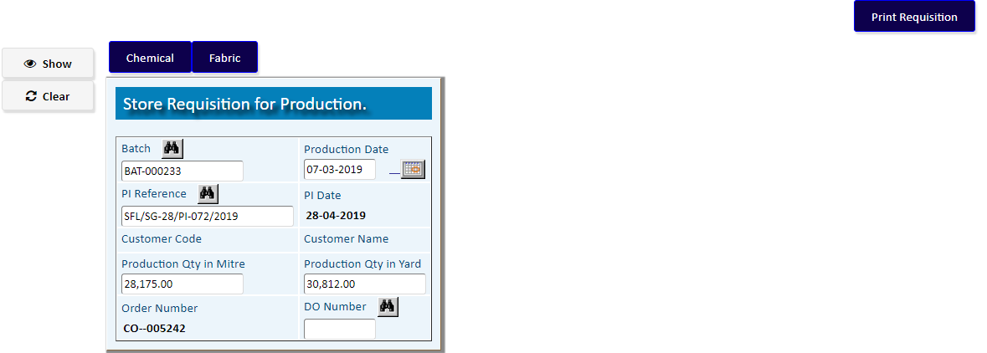

Click **Chemical** for Requisition of Chemical Items

Requisition of Chemical Items

|  |  |
| --- | --- |
| **Step 1** | Choose the **Process Name** from list & click **Add** |
| **Step 2** | A new TO of Chemical Requisition will be added |
| **Step 3** | Click **Select Item For Requisition** for Add Chemical Items |

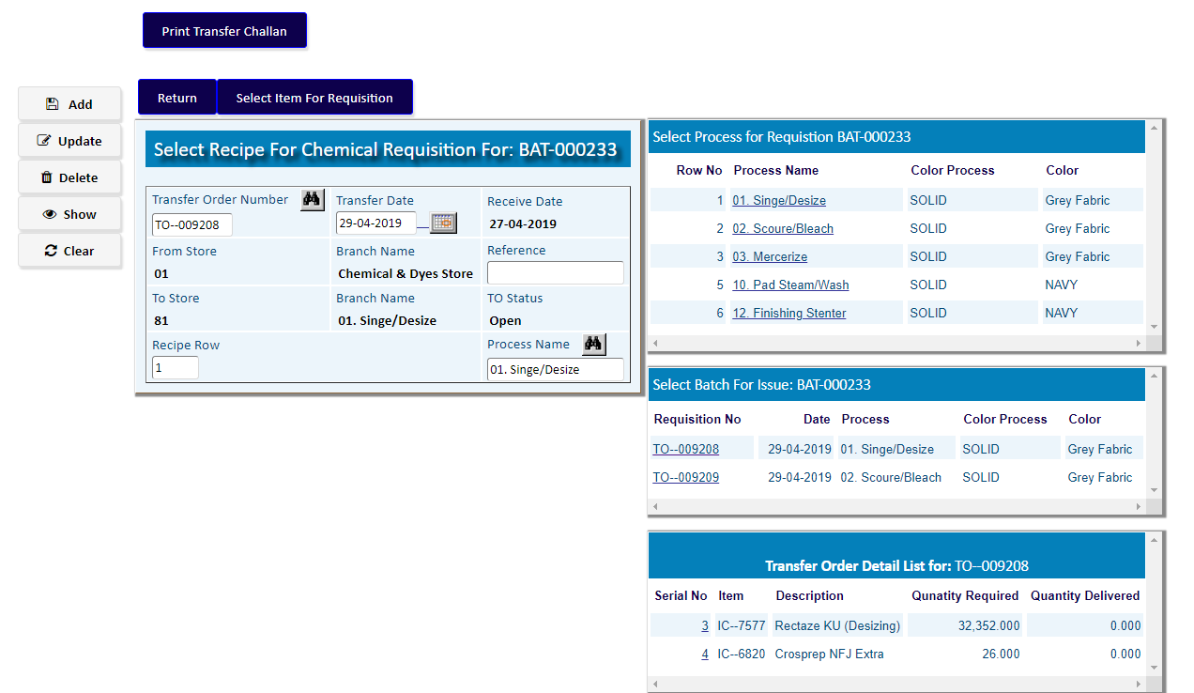

Click **Select Item for Requisition** for Add Chemical Items

Add Chemical Items with Item Code & Quantity Required

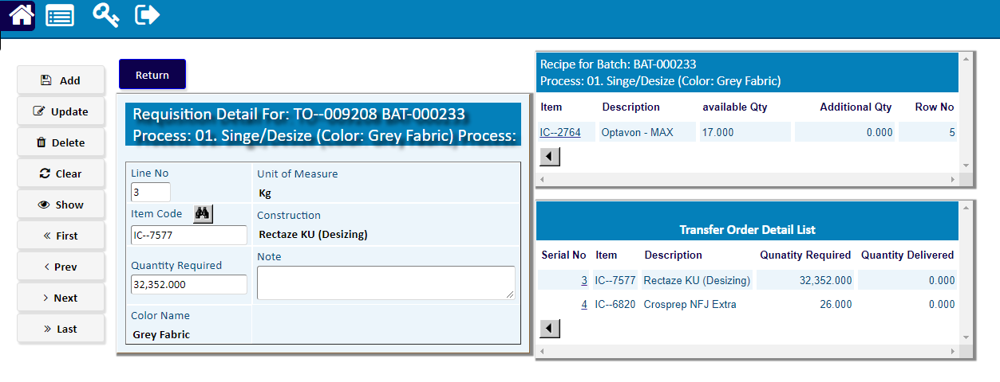

After adding Chemical Items, Click **Return**

Requisition of Fabric Items

|  |  |
| --- | --- |
| **Step 1** | Choose the **Process Name** & click **Add** |
| **Step 2** | A new TO of Fabric Requisition will be added |
| **Step 3** | Click **Select Item For Requisition** for Add Fabric Items |

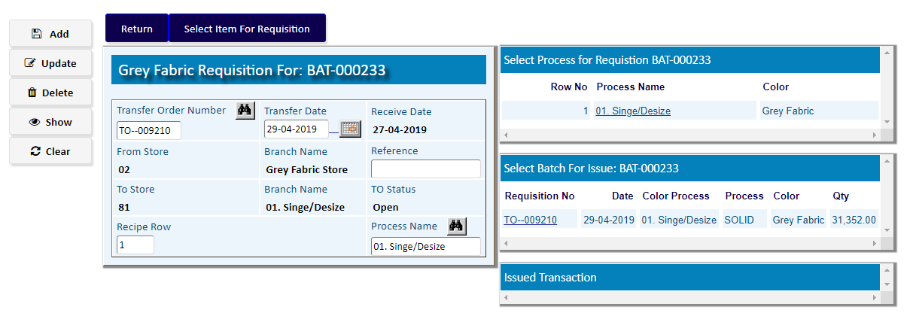

Click **Select Item for Requisition** for Add Fabric Items

Add Fabric Items with Item Code & Quantity Required

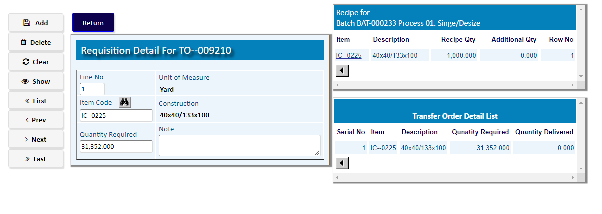

After adding Fabric Items, Click **Return**

# Issue For Production

|  |  |
| --- | --- |
| **Step 1** | Main Menu (Home Icon) **> Production >**  Issue For Production |
| **Step 2** | Choose the Batch Number & Click **Show** |
| **Step 3** | Click **Deatil** to issue the materials |

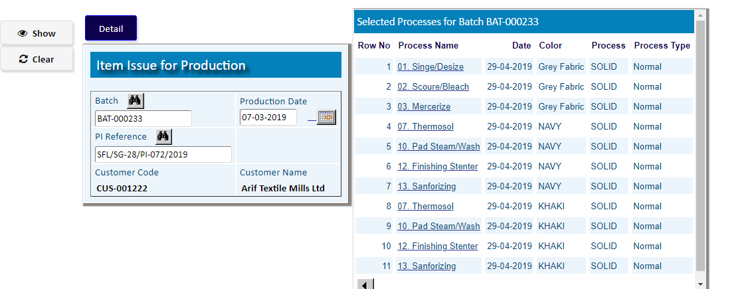

|  |  |
| --- | --- |
| **Step 1** | Select a Process Name from Side list |
| **Step 2** | Click **Issue Material** to issue the materials for that Process |

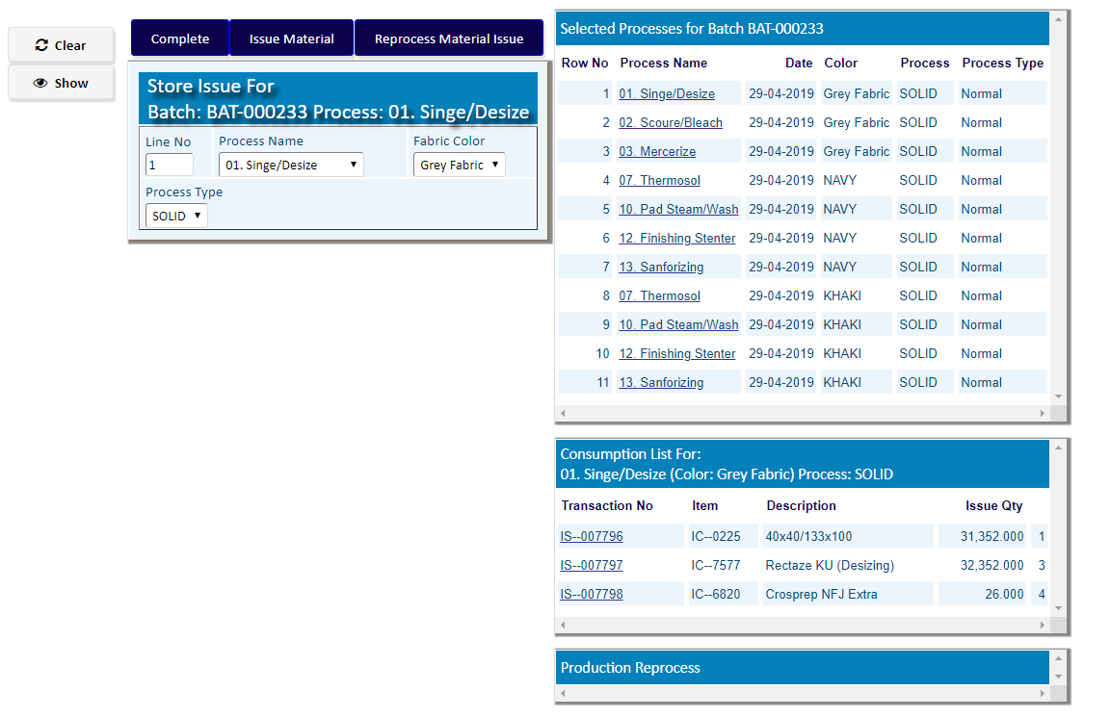

After adding Materials click **Complete**

|  |  |
| --- | --- |
| **Step 1** | Select an Item Code from Side list & click **Add** |
| **Step 2** | Click **Complete** after add |

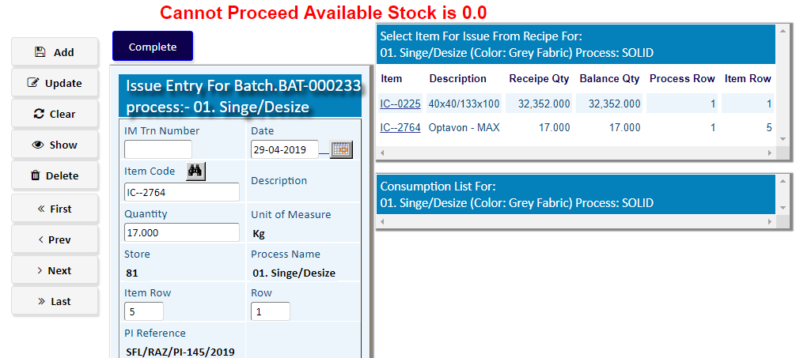

Here Stock of materials is not available.

**Whenever the Stock of materials is not available,**

**You have to go the**

**Option No. 3**

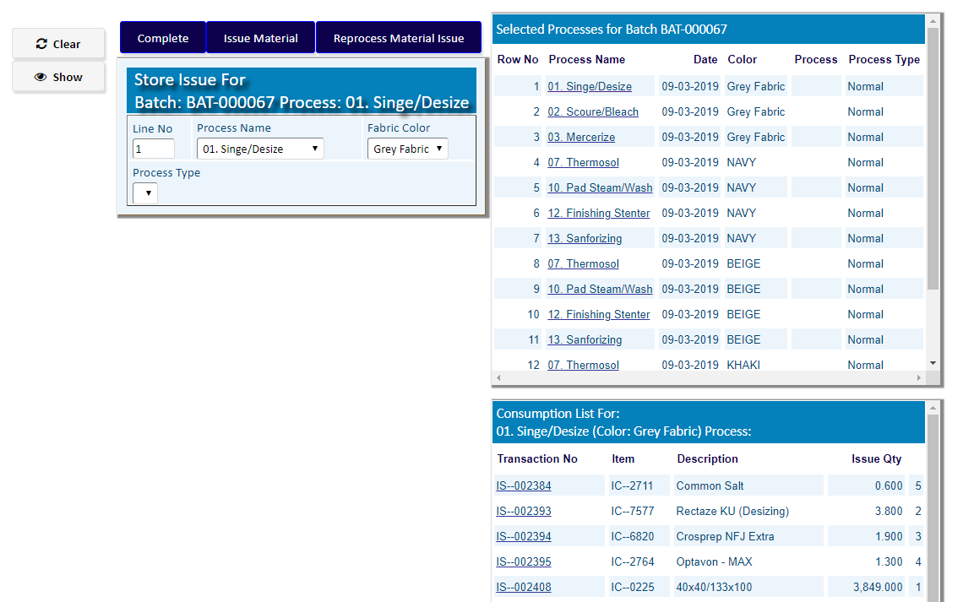

**If stock is available, click complete > complete after adding Materials for all Processes of Production**

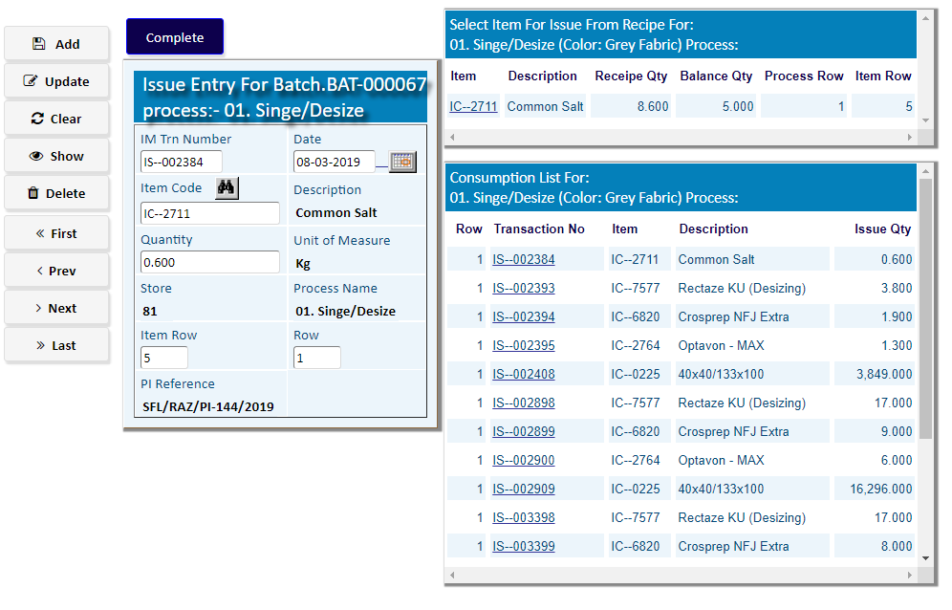

# Store Requisition (Bulk)

|  |  |
| --- | --- |
| **Step 1** | Main Menu (Home Icon) **> Production >**  Store Requisition (Bulk) |
| **Step 2** | Choose **From Store 01 ,** department & then click **Add** |
| **Step 3** | Click **Detail** to add requisition Items |

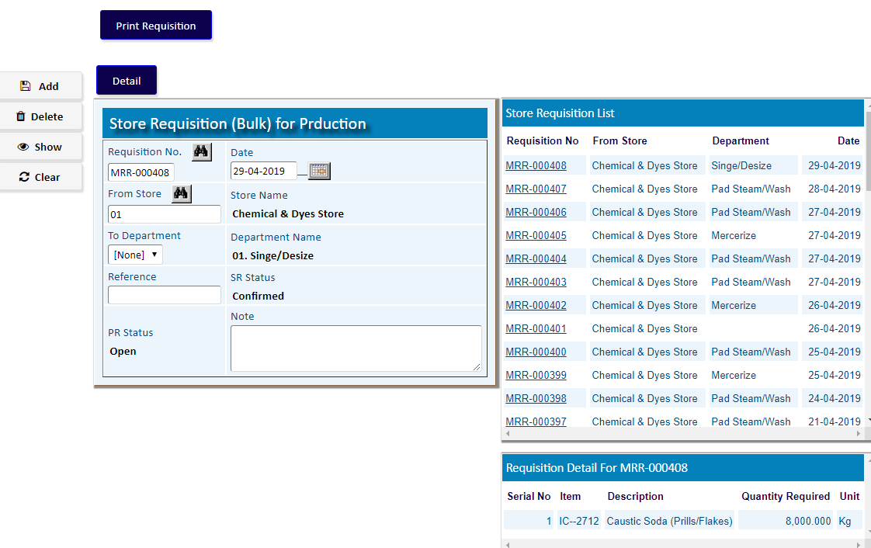

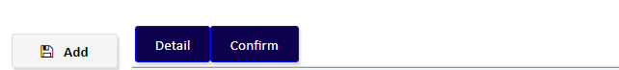

Click **Detail** to add requisition Items

1. Add Items with Item Code & Required Qty
2. Add more Items if Required
3. Click **Return**

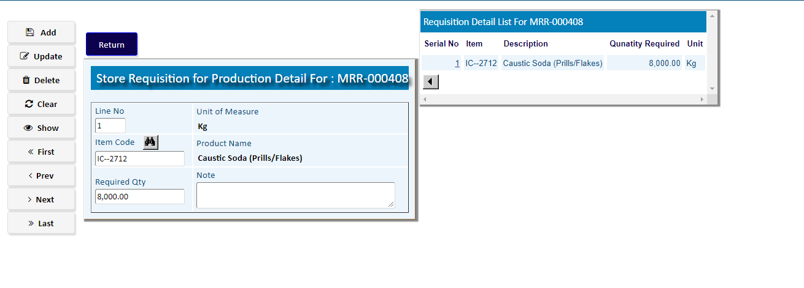

Click **Confirm** to confirm the Bulk Requisition

# Production Process

|  |  |
| --- | --- |
| **Step 1** | Main Menu (Home Icon) **> Production >**  Production Process |
| **Step 2** | Choose **Batch Number ,** & then click **Show** |
| **Step 3** | Click **Start New Process** to Start Process |

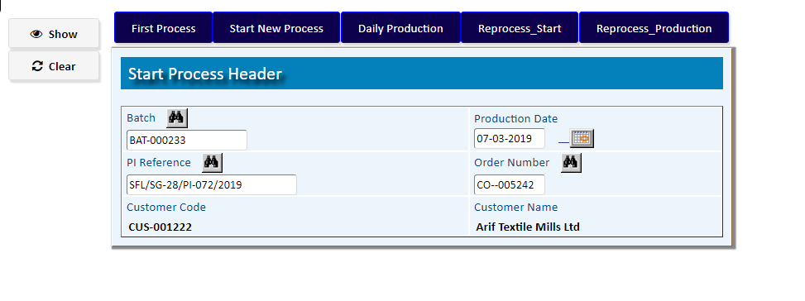

Click **Start New Process** to Start Process

|  |  |
| --- | --- |
| **Step 1** | Choose a Process Name from side list |
| **Step 2** | Write process Qty , Unit of Measure & then click **Add** |
| **Step 3** | After Adding, Click **Complete** to go Back |

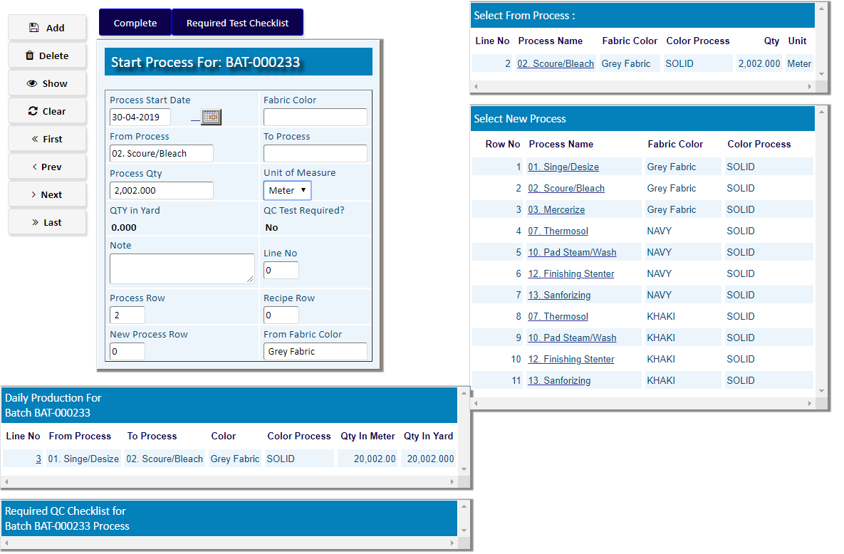

Click **Daily Production**

|  |  |
| --- | --- |
| **Step 1** | Choose a Process Name from side list |
| **Step 2** | Write Unit of Measure , Access Qty (If increase Qty), Cause of Additional & then click **Add** |
| **Step 3** | After Adding, Click **Complete** to go Back |

